DECORATE Algorithm

**Students:**

Yuval Amit 204564256

Rotem Tragash 200599678

In appendix section you can see description about all py files and their outputs (csv and png files).

All files from our algorithm running exist in GitHub

1. **Algorithm Name:**

DECORATE (Diverse Ensemble Creation by Oppositional Relabeling of Artificial Training Examples)

1. **Reference:**

Prem Melville and Raymond J. Mooney. Creating diversity in ensembles using artificial data. Information Fusion 6(1): 99–111, 2004.

1. **Motivation for the algorithm (or which problems it tries to solve?)**

"Constructing a diverse committee in which each hypothesis is as different as possible, while still maintaining consistency with the training data. All successful ensemble methods encourage diversity to some extent, **few have focused directly on the goal of maximizing diversity**. Existing methods that focus on achieving **diversity** are fairly **complex** and are not general metalearners like Bagging and Boosting which can be applied to any base learner to produce an effective.

Methods such as Boosting, Bagging and Random Forests provide diversity by sub-sampling or re-weighting the existing training examples. If the training set is **small**, this **limits** the amount of ensemble diversity that these methods can obtain"

1. **Short Description:**

DECORATE algorithm uses "strong" learners for building diverse committee. This algorithm combines ensemble and addition of different randomly artificial instances to training data set when building new committee learners.

The labels of the new artificial examples disagree with the current committee decision, therefore diversity increases for the new trained learner.

"Decorate ensures diversity on an arbitrarily large set of additional artificial examples"

1. **Pseudo-Code**

Figure 1:DECORATE Alogirthm

**DECORATE – Building the ensemble**

Input: S – a labeled training set 

E – Ensemble <classes[], C[]>

- leaner

C_size - Amount of learners in the ensemble

Imax - Maximum amount of iterations needed for building an ensemble

R_size - Factor to determine number of artificial examples to generate

1. For k=1 to CV_FOLD_NUM
   1. $T$– define train data set part of S
 $trial ←1$

 $i←1$

 $C_{iter}$ 3. = DecisionTreeClassifier( $T$- Train C on fold train data set
   4. $E=E∪C_{iter}$- Add $C_{iter}$ to $E$
   5. $Error= \frac{\sum_{TestSamples}{I(y_{pred},y_{true})}}{\# TestSamples}$, $I\left(y_{pred},y_{true}\right)=\left\{\begin{aligned}1 y_{pred} !=y_{true} \\ 0 otherwise\end{aligned}\right.$
   6. While trial<Imax AND i< $C_{iter}$
      1. R = Artificial Examples with empty label (size = R_size*(S/10))
      2. R_label = Generate Label for artificial examples
 $T=T∪R$

 $C_{iter}$    3. = DecisionTreeClassifier($T$) - Train C on fold train data set
      4. $E=E∪C_{iter}$- Add $C_{iter}$ to $E$
      5. $Error_{new}= \frac{\sum_{TestSamples}{I(y_{pred},y_{true})}}{\# TestSamples}$, $I\left(y_{pred},y_{true}\right)=\left\{\begin{aligned}1 y_{pred} !=y_{true} \\ 0 otherwise\end{aligned}\right.$
      6. if $Error_{new}<Error$
 $Error<Error_{new}$

 $i++$

    7. Else
 $E=E-C_{iter}$

 $trials++$

 7. END Whie

**DECORATE – Classify an instance:**

Input: S – Test instances needed to be labeled

$$T_{predict}={argmax}_{EnsembleClasses}\left(\frac{\sum_{c∈E}{Predict_{C}\left(T\right)}}{length\left(E\right)}\right),Predict_{c}-is predict probabilities of DecisionTreeClassifier$$

Figure 2: DECORATE Algorithm - Artificial Examples Generation

**DECORATE – Create Artificial Examples:**

Input: S – Train fold instances

R_size

For feature in S.features

if feature is binary (for categorical features: they are converted to one hot vectors)

Generate n (=R_size*|S|) values based on distribution derived from probability of the distinct values' occurrence.

Else (numerical features)

Generate n (=R_size*|S|) values based on Gaussian distribution defined by mean and standard deviation of the origin numerical feature values.

End For

**DECORATE – Classify Artificial Examples:**

Input: S – Train fold instances

$$P_{s}=Predict_{Ensemble}\left(S\right), generate probabilities for each class$$

$$P_{s}= \frac{P_{s}}{norm(P_{s})}$$

$$Label= {argmax}_{EnsembleClasses}(\frac{\frac{1}{P_{s}}}{sum(\frac{1}{p_{s}})})$$

**6. Algorithm Explanation:**

There are 4 steps when running the algorithm:

* PreProcessing
* Hyper Parameters Random Search
* Algorithm (DECORATE)
* Evaluation

***PreProcessing:***

In pre-processing there is conversion of categorical field into one hot vectors which are concatenated into the origin dataframe.

***Hyper Parameters Random Search:***

50 iterations of 3 cross validation were made in order to find the hyper parameters (C_Size

, Imax, R_Size) which got the highest accuracy.

***Algorithm (DECORATE):***

The algorithm is depicted in Figure1 and Figure2.

CV_FOLD_NUM=10

**Evaluation:**

Calculated the following measurements for each fold in the 10 cv:

* Accuracy
* TPR
* FPR
* Prediction
* AUC
* PR-Curve
* Train Runtime
* Test Runtime

**7. Illustration**

* Table 5 below includes the initial baseball dataset we use for the running example
* Input for DECORATE algorithm:

k of cv=2

Imax=3

C_size=3

R_size=0.2

* You can see below the test results for the running example.

There are 2 folds, for each fold we run the DECORATE algorithm, each algorithm running makes fit for the first time (section 1.4 in pseudo code) with all train data set without artificial example and for the second and third time (section 1.7 in pseudo code) it makes fit with artificial examples.

**Fold 1:**

|  |  |  |  |  |
| --- | --- | --- | --- | --- |
|  |  | **y_predict** | | |
|  |  | **0** | **1** | **2** |
| **y_true** | **0** | 43 | 0 | 0 |
| **1** | 0 | 2 | 0 |
| **2** | 4 | 2 | 0 |

Table 1:First and second (with artificial examples) train Error=0.117

|  |  |  |  |  |
| --- | --- | --- | --- | --- |
|  |  | **y_predict** | | |
|  |  | **0** | **1** | **2** |
| **y_true** | **0** | 43 | 0 | 0 |
| **1** | 1 | 1 | 0 |
| **2** | 6 | 0 | 0 |

Table 2: Third train (with artificial examples) Error=0.137

Final fold1 accuracy = 0.882

**Fold 2:**

|  |  |  |  |  |
| --- | --- | --- | --- | --- |
|  |  | **y_predict** | | |
|  |  | **0** | **1** | **2** |
| **y_true** | **0** | 43 | 0 | 3 |
| **1** | 2 | 2 | 0 |
| **2** | 0 | 0 | 0 |

Table 3: First train Error=0.1

|  |  |  |  |  |
| --- | --- | --- | --- | --- |
|  |  | **y_predict** | | |
|  |  | **0** | **1** | **2** |
| **y_true** | **0** | 44 | 0 | 2 |
| **1** | 2 | 2 | 0 |
| **2** | 0 | 0 | 0 |

Table 4: Second (with artificial examples) and third trains (with artificial examples) Error=0.08

Final fold2 accuracy = 0.92

Final accuracy = 0.89



Table 5: baseball data set

**8. Strengths**

Decorate algorithm strength is focused on increasing the diversity of the examples. Allowing it to outperform other algorithms on small database, making better generalization on these datasets.

**9. Drawbacks**

The most significant drawback of DECORATE algorithm is that it is very time consuming, making it less desirable on large datasets.

**10. Experimental Results**

**Meta learner scores:**

We tested the meta learner with Leave One Out on the datasets which leads to the following scores:

|  |  |  |  |  |  |
| --- | --- | --- | --- | --- | --- |
| **ACC** | **TPR** | **FPR** | **PPV** | **AUC ROC** | **AUC PRECISION** |
| 0.69 | 0.69 | 0.44 | 0.67 | 0.63 | 0.84 |

**Feature importance graphs**.

Shap

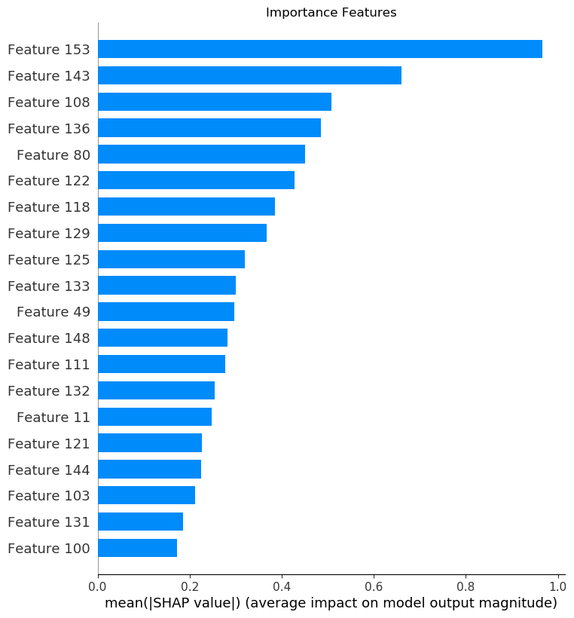

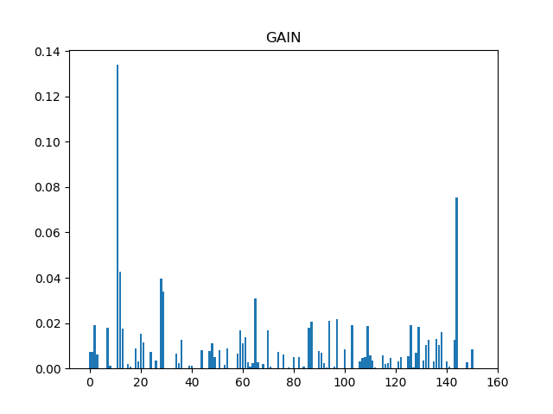

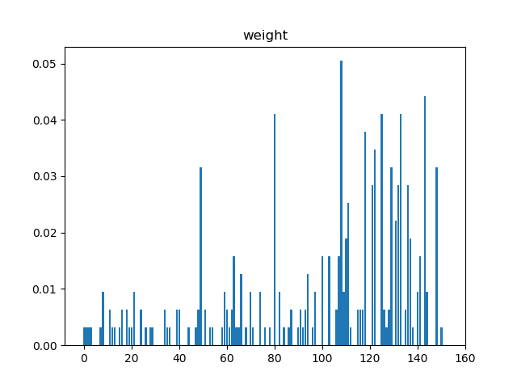

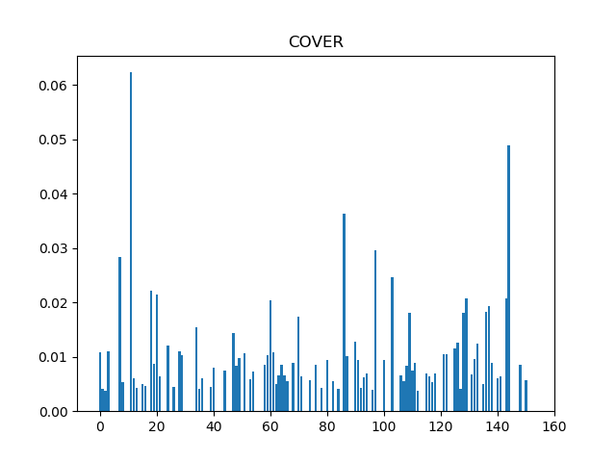

**11. Conclusions**

The algorithms perform better or at least similarly in small datasets on all measures we checked. We would recommend using it on these sets. However, in case of large datasets, it should be avoided and other algorithms should be used.

**12. Citations**

* Diversity is known to be an important factor which affects the generalization performance of Ensemble classifiers. **(**Li X, Wang L, Sung E. AdaBoost with SVM based component classifier. Eng Appl Artif Intell. 2008;21(5):785–795**)**
* To improve the performance of the single classifier approaches the combination of multiple classifiers has been proposed in the field of machine learning. ( Nanni, L., & Lumini, A. (2009). An experimental comparison of ensemble of classifiers for bankruptcy prediction and credit scoring. Expert Systems with Applications, 36, 3028-3033)
* Melville and Mooney (2005) presented a new method RN/11/02 Page 4 Ensemble Learning Martin Sewell for generating ensembles, DECORATE (Diverse Ensemble Creation by Oppositional Relabeling of Artificial Training Examples), that directly constructs diverse hypotheses using additional artificially-constructed training examples. Their approach consistently outperformed the base classifier, bagging and random forests; and outperformed AdaBoost on small training sets and achieved comparable performance on larger training sets.(G. Brown, J. Wyatt, R. Harris, and X. Yao, “Diversity creation methods: A survey and categorisation,” Inf. Fusion, vol. 6, no. 1, pp. 5–20, 2005.)

**Appendix:**

**Files:**

|  |  |  |
| --- | --- | --- |
| **.py file** | **File description** | **files outputs** |
| main | Includes final report framework generation and all function calls (decorate and gbm) | *tests_results.csv*- final report |
| pre_processing | This file include the preprocessing of the data set, such as converting categorical features into one hot vectors |  |
| common | Includes the functions of measurements calculations |  |
| gbm | GBM algorithm , it includes hyper parameters random search and 10 cv |  |
| decorate | DECORATE algorithm , it includes hyper parameters random search and 10 cv |  |
| statistic_test | Input for this file: *tests_results.csv*  This file includes Mann-Whitney U test, for comparing DECORATE and GBM algorithms | *Statistic_test.txt* – includes the statistic tests results in the first row, and in the second row if there was a rejection of the test |
| meta_learner | Input for this file: *tests_results.csv*  This file includes meta leaner which define which algorithm will be better according to meta features | * *meta_added_class.csv* - meta features file with the **class which is set according to tests_results.csv** * *shap.csv* - importance * *importance results.csv* -importance features according to **gain, weight and cover** measurements. * *y_predicted.csv* – **predicted good algorithm (=classes) for each data set file** * *meta_results.csv* – test measurements (Accuracy, TPR, FPR, PPV, AUC_roc, AUC_pr) * *importance_features.png* - importance features chart * *gain.png* - gain chart * *weight.png* - weight chart * *cover.png* - cover |